**Veeva Events Simplification:**

**Functional and Technical Design**

Document Version: X.Y

Document ID: Veeva Events Management – Functional and Technical Design



Bristol-Myers Squibb

Enterprise Services

**Signatories**

**Prepared by:**

By signing this **Technical Design**, I tender it for approval.

|  |  |  |
| --- | --- | --- |
| **Murugesh** | **Veeva EM Solution Architect** | **Date** |

**Approved by:**

I have reviewed this **Technical Design**, and accept and approve of the document’s provisions as stated herein.

|  |  |  |
| --- | --- | --- |
| **Murugesh Naidu** | **Veeva EM Solution Architect** | **Date** |

|  |  |  |
| --- | --- | --- |
| **Anandan, Seemesh** | **BMS – Veeva EM Project IT Program Manager** | **Date** |

**Version History**

|  |  |  |  |
| --- | --- | --- | --- |
| **Version** | **Date** | **Revised By** | **Changes Made - Reasons for the Change** |
| 1.0 | 3/14/2017 | Murugesh Naidu |  |

### Introduction

[Traceability Requirements 76.0, 83.0, 84.0, 85.0, 86.0, 87.0]

Veeva EM Simplification release aims to simplify the existing Veeva Events Management release that was released for Germany and Brazil markets. As part of simplification, several modules such as Contracting, ICF etc have been removed from the BMS overall solution.

At a high-level, the overall simplified EM Solution consists of:

* Simplified Events Configuration – Setup of Veeva product supported configuration data
* Simplified Service Provider Pool Setup – Using ever green Speaker Qualification records as MSAs
* Simplified Activity Service Provider and Audience screens

### Simplified Events Configuration and Setup

[Traceability Requirements 76.0, 83.0, 84.0, 85.0, 86.0, 87.0]

The core simplified Events Management build consists of two distinct flows:

* EM Activities with Approval
* EM Activities without Approval

In any given market, users can only ever create one type of EM Activity. There is no “Activity type selection” step when creating EM Activities. The criteria that decides if a market uses Activity Approvals or not is a business decision and is configured using Veeva’s out of the box Event Configuration module prior to going live.

Access and visibility to EM Activity screens and related lists depends on several factors:

* System access as defined/regulated by Permissions Sets/Profiles
* Activity Team Member role – A defined role for the logged in user on the EM Activity
* User’s Role Hierarchy

### Activity Team Member roles

System defines the following Activity Team Member roles in the system. These roles apply to the Activity Team Member related list and control what type of access the user has on the Activity (as defined by the Access Matrix in subsequent sections)

* **Activity Owner (Organizer_vod)** – this role is system defined and users cannot pick this role from the UI. By default, the user that creates the EM Activity gets assigned this role under Activity Team Member section. Activity Owners are the complete owners of the Activity with most access rights except Unlocking the Activity.
* **Editor** – This role is user defined role that users can assign to Activity Team Member records when they add Team Members under Activity Team Member section. This is designed to provide Edit access to the Activity record, similar to the Activity Owner record. These are usually users that maybe co-hosting the Activity with the Activity Owner and need Edit access to the Activity
* **Read Only** – This role is also user defined role that users can assign via the UI when creating Activity Team Member records. This role is designed to provide only Read Only access to the Activity
* **Approver (Approver_vod)** – This is a System Defined role that gets assigned to a Team Member that receives Activity Approval requests OR gets added as a PO Approver on the EM Activity
* **Service Coordinator** – This role is assigned by users via the UI to Team Members from the EMCoE team. This role is defined to have the maximum access to the Activity including the right to unlock the Activity from an Archived status

### EM Activities Without Approval

EM Activities that do not need approval consist of following statuses and possible transitions:

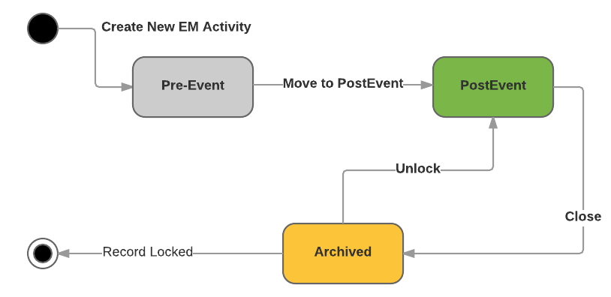

### Related List Grid by Activity Team Member roles

|  |  |  |  |
| --- | --- | --- | --- |
| *Roles 🡺* | **DefinedRole: Activity Owner/Service Coordinator/Editor/Hierarchical/SysAdmin/Approver** | | **DefinedRole: Read Only** |
| *Statuses🡺*  *Related List (below)* | **Pre-Event, Post-Event** | **Archived** | **Pre-Event, Post-Event, Archived** |
| Activity Detail | CRUD | R | R |
| Activity Budget | CRD | R | R |
| Expense Estimate [Budget Overview] | CRUD**1** | R | R |
| Expenses | CRUD | R | R |
| Activity Service Providers | CRUD | R | R |
| Audience | CRUD | R | R |
| Activity Materials | CRUD | R | R |
| Activity Team Members | CRD | R | R |
| EM Activities | CRUD**2** | R | R |
| Open Tasks3 | CRUD | CRUD | CRUD |
| Attachments4 | CRUD | CRUD | CRUD |
| Task History3 | SYSTEM MANAGED | SYSTEM MANAGED | SYSTEM MANAGED |
| Activity Histories | SYSTEM MANAGED | SYSTEM MANAGED | SYSTEM MANAGED |
|  |  |  |  |
|  |  |  |  |

### Sample EM Activity Snapshot – Pre-Event as Activity Owner

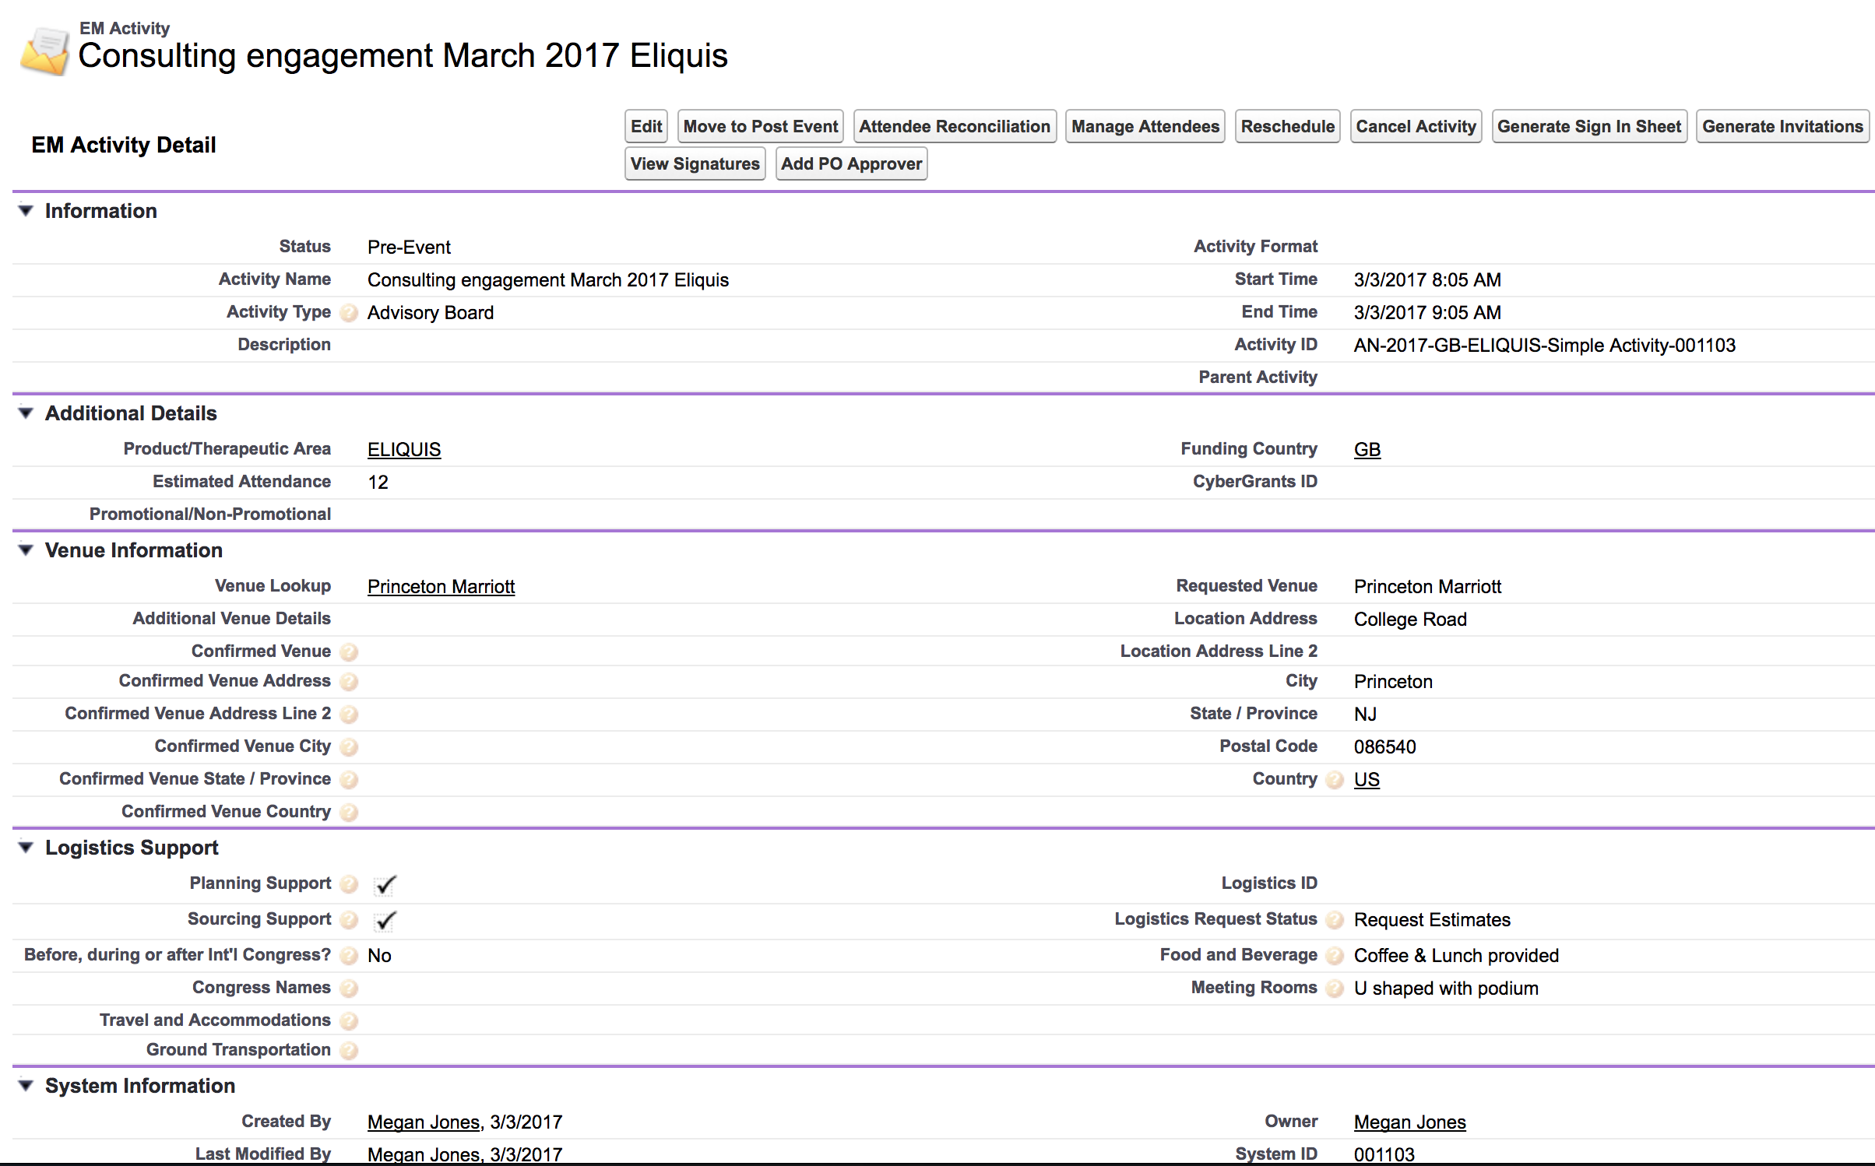

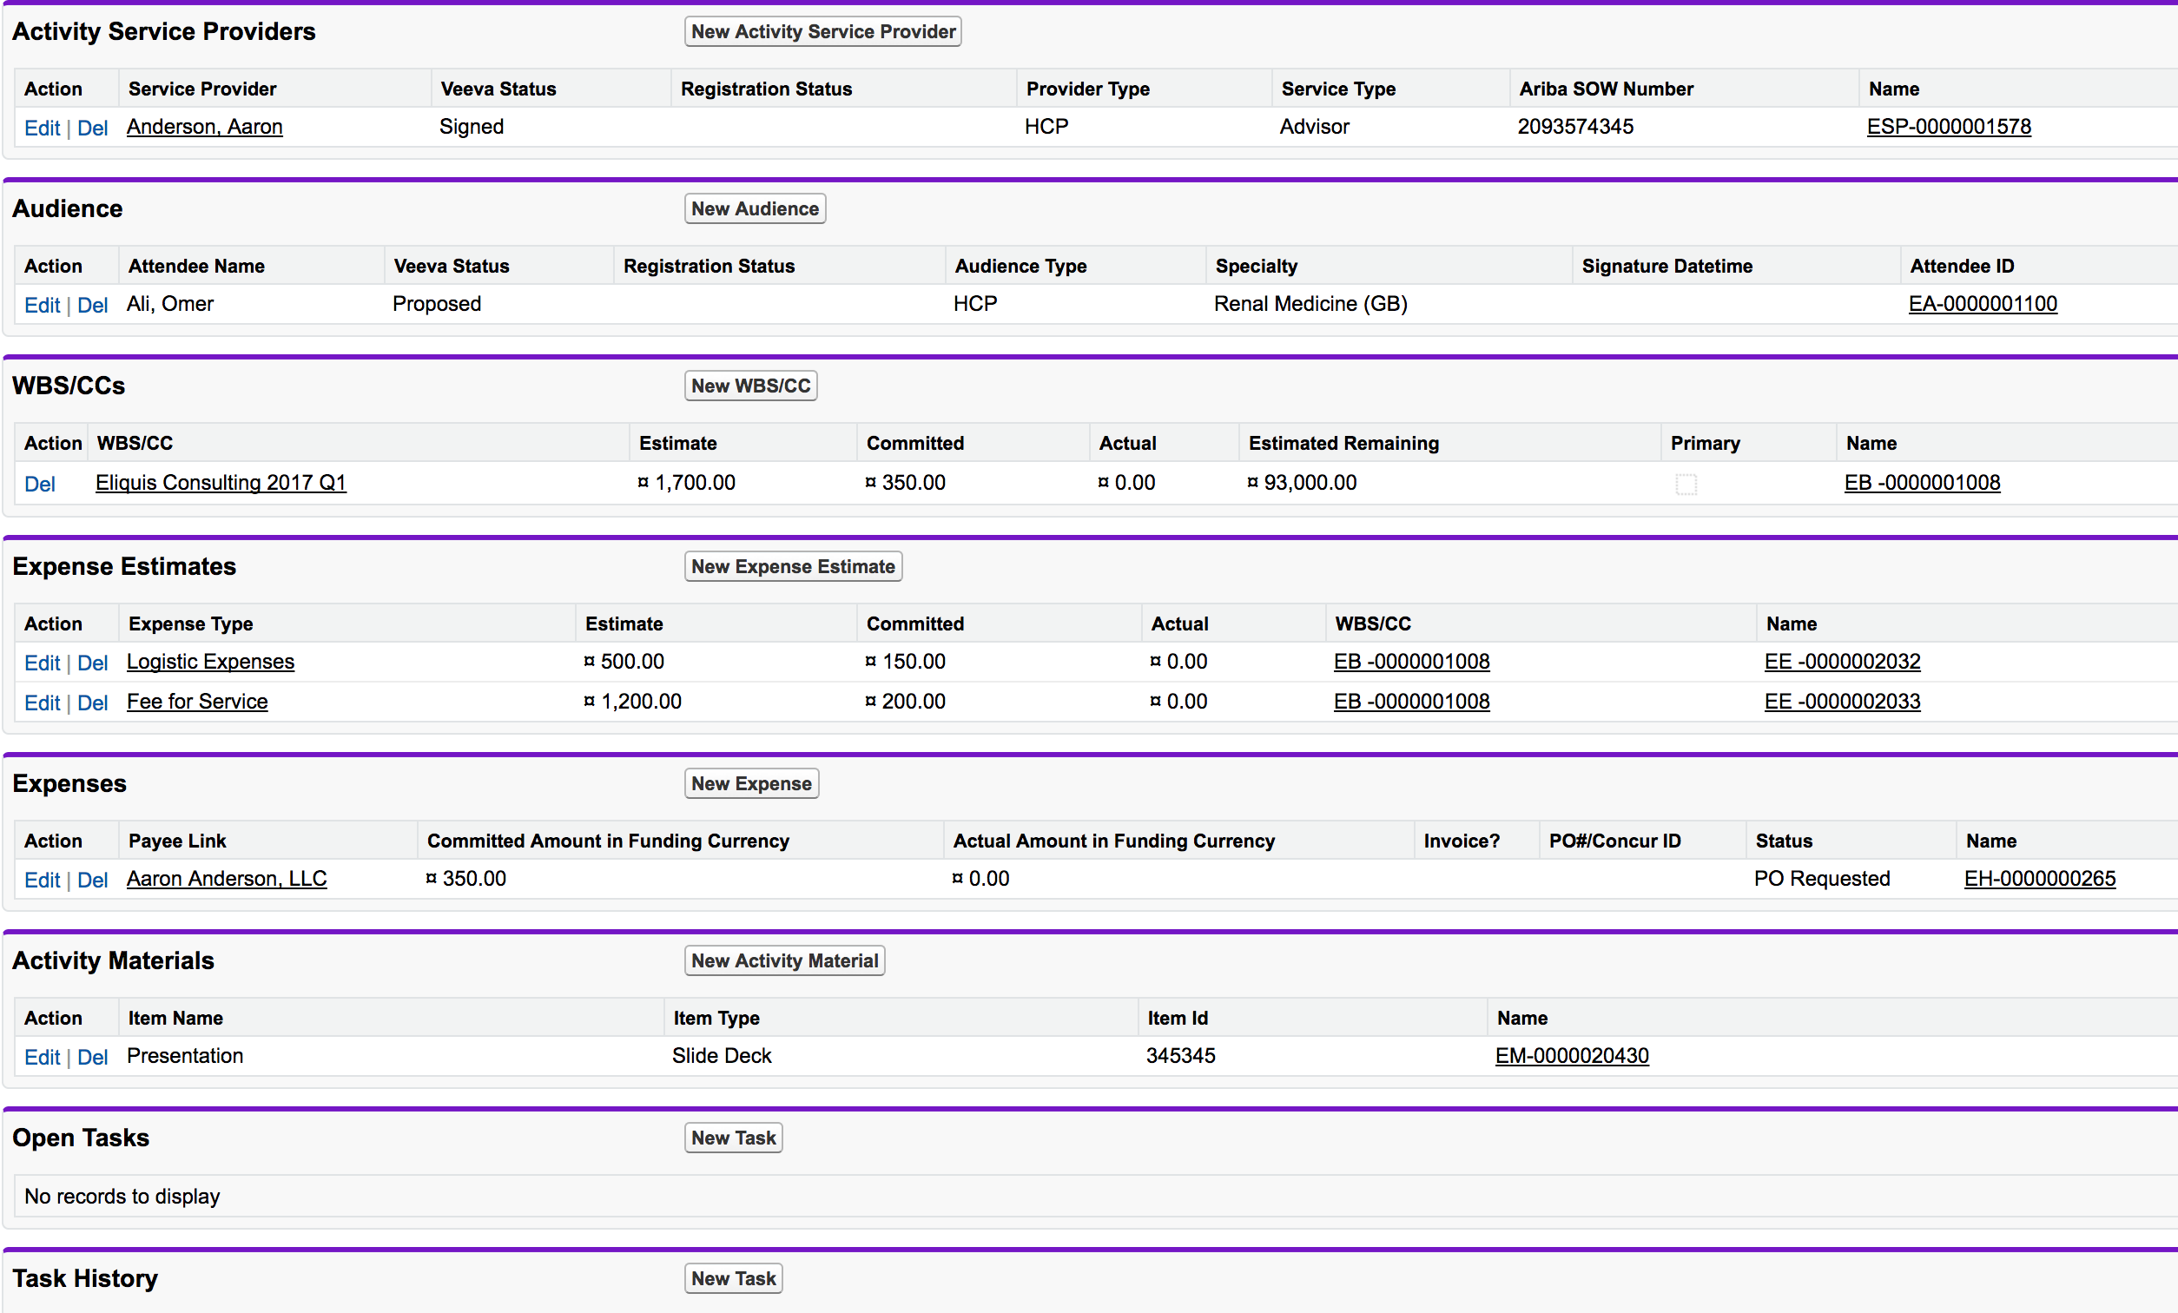

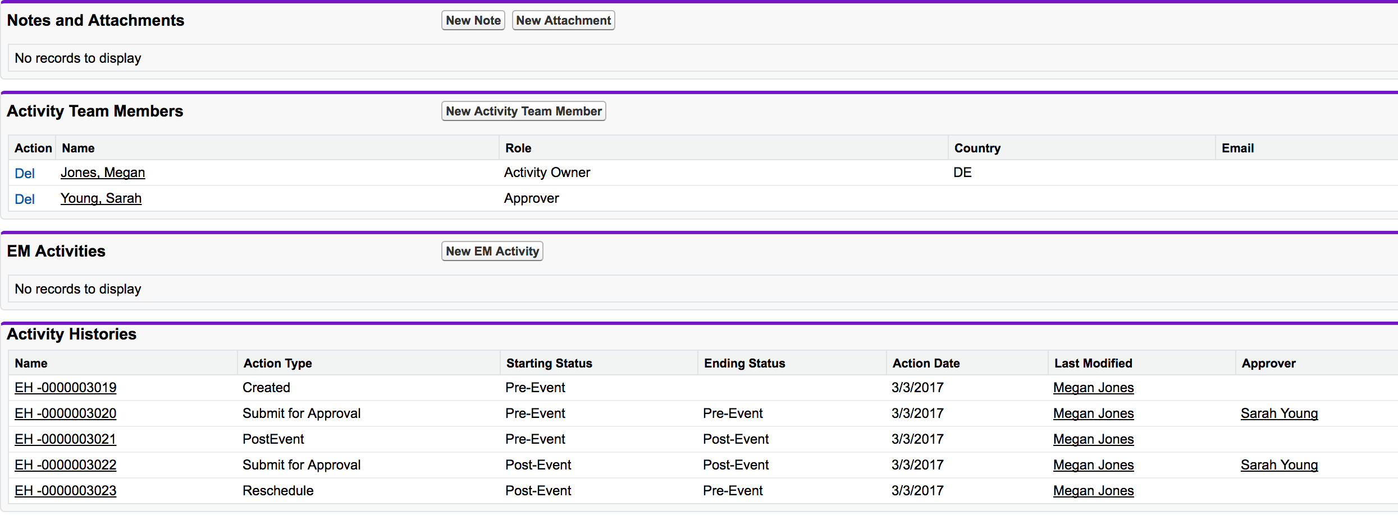

### Button Visibility Access grid (Without Approvals)

**Legend:**

|  |  |
| --- | --- |
| **iB** | Available on iPad and Browser |
| **B** | Available on Browser Only |
| **i** | Available on iPad Only |
| **NA** | Not Available on any platform |

|  |  |  |  |
| --- | --- | --- | --- |
|  | **DefinedRole: Activity Owner** | | |
|  | **Pre-Event** | **Post-Event** | **Archived** |
| Edit | iB | iB | NA |
| Move to Post Event | iB | NA | NA |
| Close | NA | iB | NA |
| Add PO Approver | iB | iB | NA |
| Attendee Reconciliation | iB | iB | NA |
| Manage Attendees | iB | iB | NA |
| Reschedule | iB | iB | NA |
| Cancel Activity | iB | iB | NA |
| Generate-Sign in Sheet | iB | iB | NA |
| Generate INvitations | iB | iB | NA |
| View_Signatures_vod | B | B | NA |
| Unlock | NA | NA | NA |
| Sign-in Sheet [Digital] | i | i | NA |

|  |  |  |  |
| --- | --- | --- | --- |
|  | **DefinedRole: Service Coordinator** | | |
|  | **Pre-Event** | **Post-Event** | **Archived** |
| Edit | iB | iB | NA |
| Move to Post Event | iB | NA | NA |
| Close | NA | iB | NA |
| Add PO Approver | iB | iB | NA |
| Attendee Reconciliation | iB | iB | NA |
| Manage Attendees | iB | iB | NA |
| Reschedule | iB | iB | NA |
| Cancel Activity | iB | iB | NA |
| Generate-Sign in Sheet | iB | iB | NA |
| Generate INvitations | iB | iB | NA |
| View_Signatures_vod | B | B | NA |
| Unlock | NA | NA | iB |
| Sign-in Sheet [Digital] | i | i | NA |

|  |  |  |  |
| --- | --- | --- | --- |
|  | **DefinedRole: Editor** | | |
|  | **Pre-Event** | **Post-Event** | **Archived** |
| Edit | iB | iB | NA |
| Move to Post Event | iB | NA | NA |
| Close | NA | iB | NA |
| Add PO Approver | iB | iB | NA |
| Attendee Reconciliation | iB | iB | NA |
| Manage Attendees | iB | iB | NA |
| Reschedule | iB | iB | NA |
| Cancel Activity | iB | iB | NA |
| Generate-Sign in Sheet | iB | iB | NA |
| Generate INvitations | iB | iB | NA |
| View_Signatures_vod | B | B | NA |
| Unlock | NA | NA | NA |
| Sign-in Sheet [Digital] | i | i | NA |

|  |  |  |  |
| --- | --- | --- | --- |
|  | **DefinedRole: Read Only** | | |
|  | **Pre-Event** | **Post-Event** | **Archived** |
| Edit | NA | NA | NA |
| Move to Post Event | NA | NA | NA |
| Close | NA | NA | NA |
| Add PO Approver | NA | NA | NA |
| Attendee Reconciliation | NA | NA | NA |
| Manage Attendees | NA | NA | NA |
| Reschedule | NA | NA | NA |
| Cancel Activity | NA | NA | NA |
| Generate-Sign in Sheet | NA | NA | NA |
| Generate INvitations | NA | NA | NA |
| View_Signatures_vod | NA | NA | NA |
| Unlock | NA | NA | NA |
| Sign-in Sheet [Digital] | NA | NA | NA |

|  |  |  |  |
| --- | --- | --- | --- |
|  | **DefinedRole: Approver** | | |
|  | **Pre-Event** | **Post-Event** | **Archived** |
| Edit | iB | iB | NA |
| Move to Post Event | iB | NA | NA |
| Close | NA | iB | NA |
| Add PO Approver | iB | iB | NA |
| Attendee Reconciliation | iB | iB | NA |
| Manage Attendees | iB | iB | NA |
| Reschedule | iB | iB | NA |
| Cancel Activity | iB | iB | NA |
| Generate-Sign in Sheet | iB | iB | NA |
| Generate INvitations | iB | iB | NA |
| View_Signatures_vod | B | B | NA |
| Unlock | NA | NA | NA |
| Sign-in Sheet [Digital] | i | i | NA |

|  |  |  |  |
| --- | --- | --- | --- |
|  | **System Admin Profile** | | |
|  | **Pre-Event** | **Post-Event** | **Archived** |
| Edit | iB | iB | NA |
| Move to Post Event | iB | NA | NA |
| Close | NA | iB | NA |
| Add PO Approver | iB | iB | NA |
| Attendee Reconciliation | iB | iB | NA |
| Manage Attendees | iB | iB | NA |
| Reschedule | iB | iB | NA |
| Cancel Activity | iB | iB | NA |
| Generate-Sign in Sheet | iB | iB | NA |
| Generate INvitations | iB | iB | NA |
| View_Signatures_vod | B | B | NA |
| Unlock | NA | NA | iB |
| Sign-in Sheet [Digital] | i | i | NA |

|  |  |  |  |
| --- | --- | --- | --- |
|  | **Hierarchical/Non-defined Role** | | |
|  | **Pre-Event** | **Post-Event** | **Archived** |
| Edit | iB | iB | NA |
| Move to Post Event | iB | NA | NA |
| Close | NA | iB | NA |
| Add PO Approver | iB | iB | NA |
| Attendee Reconciliation | iB | iB | NA |
| Manage Attendees | iB | iB | NA |
| Reschedule | iB | iB | NA |
| Cancel Activity | iB | iB | NA |
| Generate-Sign in Sheet | iB | iB | NA |
| Generate INvitations | iB | iB | NA |
| View_Signatures_vod | B | B | NA |
| Unlock | NA | NA | NA |
| Sign-in Sheet [Digital] | i | i | NA |

ECs requiring Approvals vs No Approvals

* Event Config Approval Requirements
* Event History
* Event Audit Fields?
* Special Roles – System Admin, Hierarchy

### Page Layouts

### EM Budget and Activity Budgets

### Activity Materials

**Impacts to Germany Build**

**Permission sets**

Page layouts with Fields